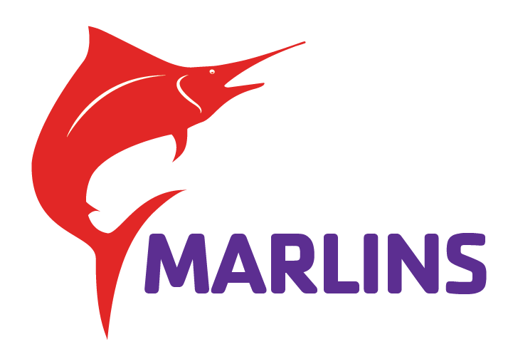
Marlins Swim Team Wishlist
*These are items that our swim team would like but we may not have the budget to purchase at this time. Please note that these are NOT required items. If you are willing to donate any of these items to our team please contact brady.carlson@ymcamn.org and you will be provided with a form to fill out regarding donations etc..* Families are not required to donate to our program.

- Assorted Flippers
- Breaststroke Fins
- PVC Dowel Sticks
- Racket Balls or Ping Pong balls
- Bucket of Dice (fun swims)
- Plastic Pumpkins (fun relays)
- Paddles
- Stop watches (with split function)
- Extra Goggles

